**Example outputs:**

**After running in Jupyter Notebook:**

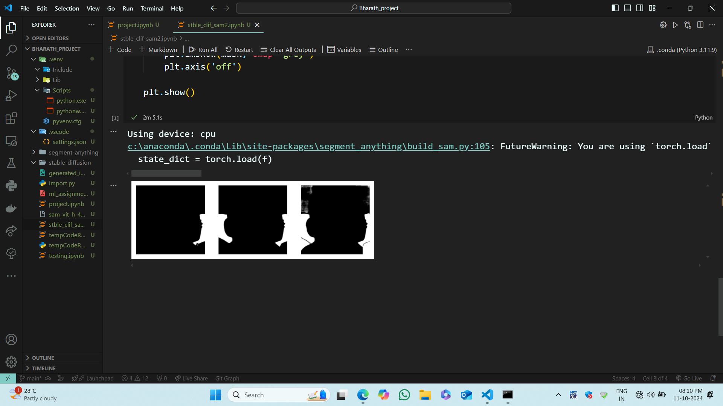

**Running flask server in Pycharm:**

**After giving a prompt in index.html**

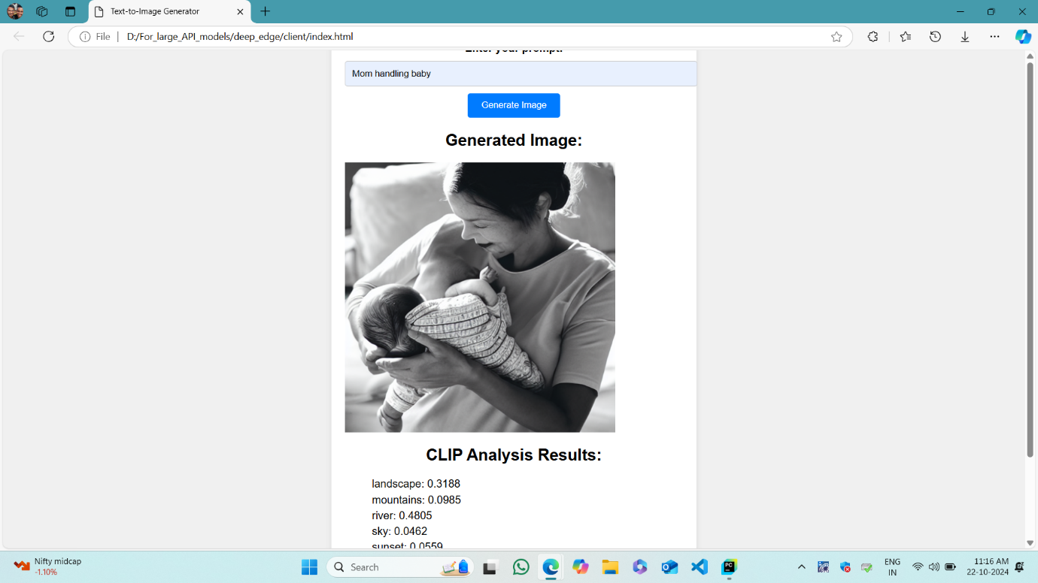

**After testing in postman:**

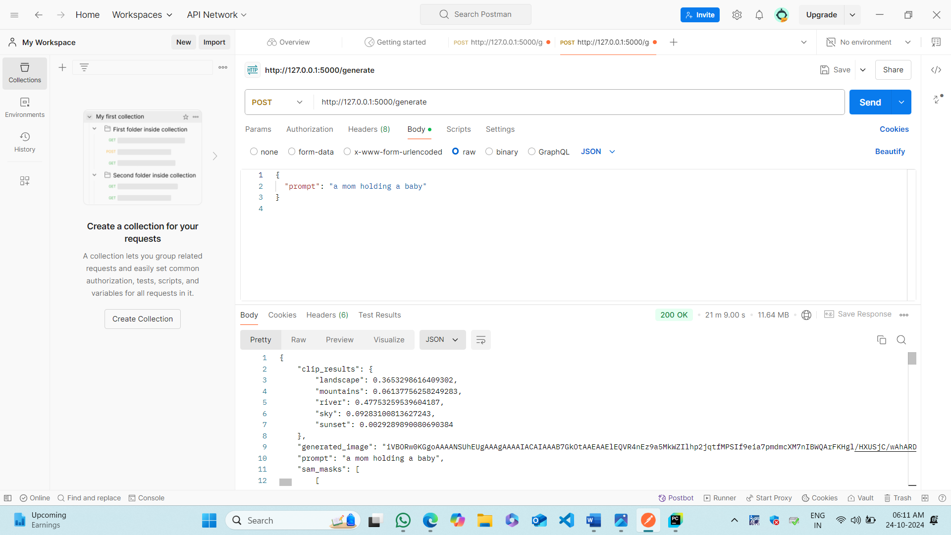

**Docker:**

**After creating the image:**

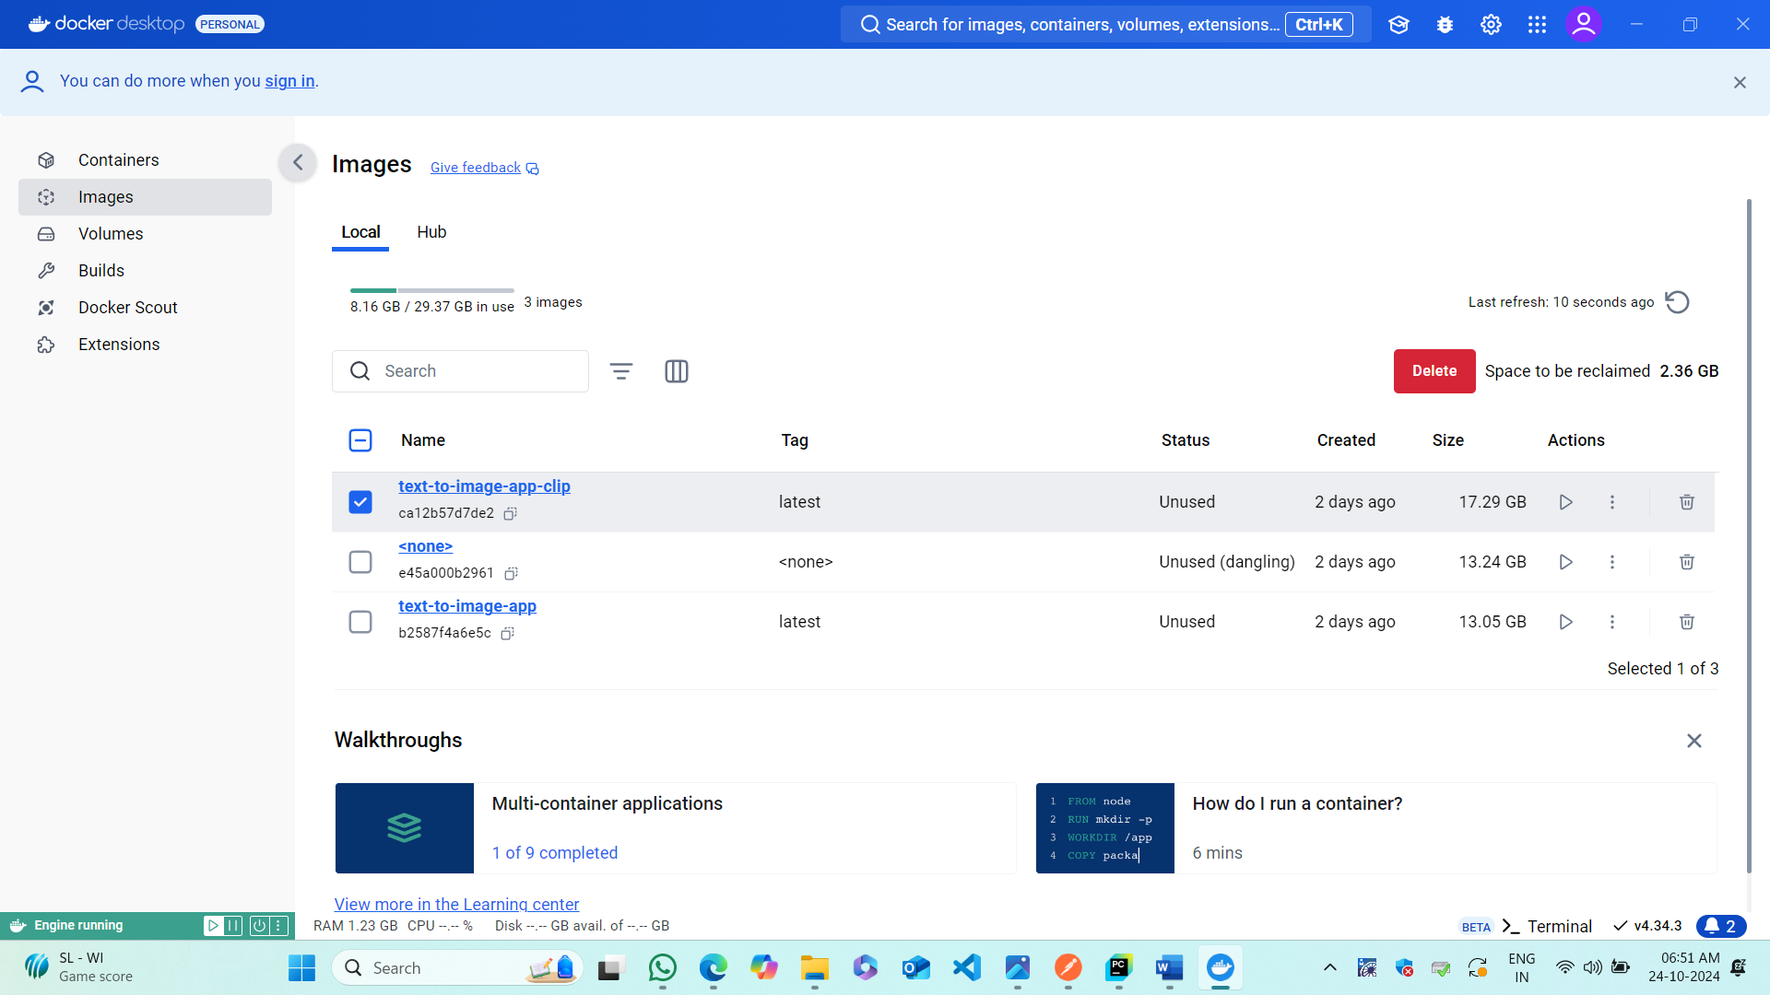

**After creating a container:**

**Container in normal stage:**

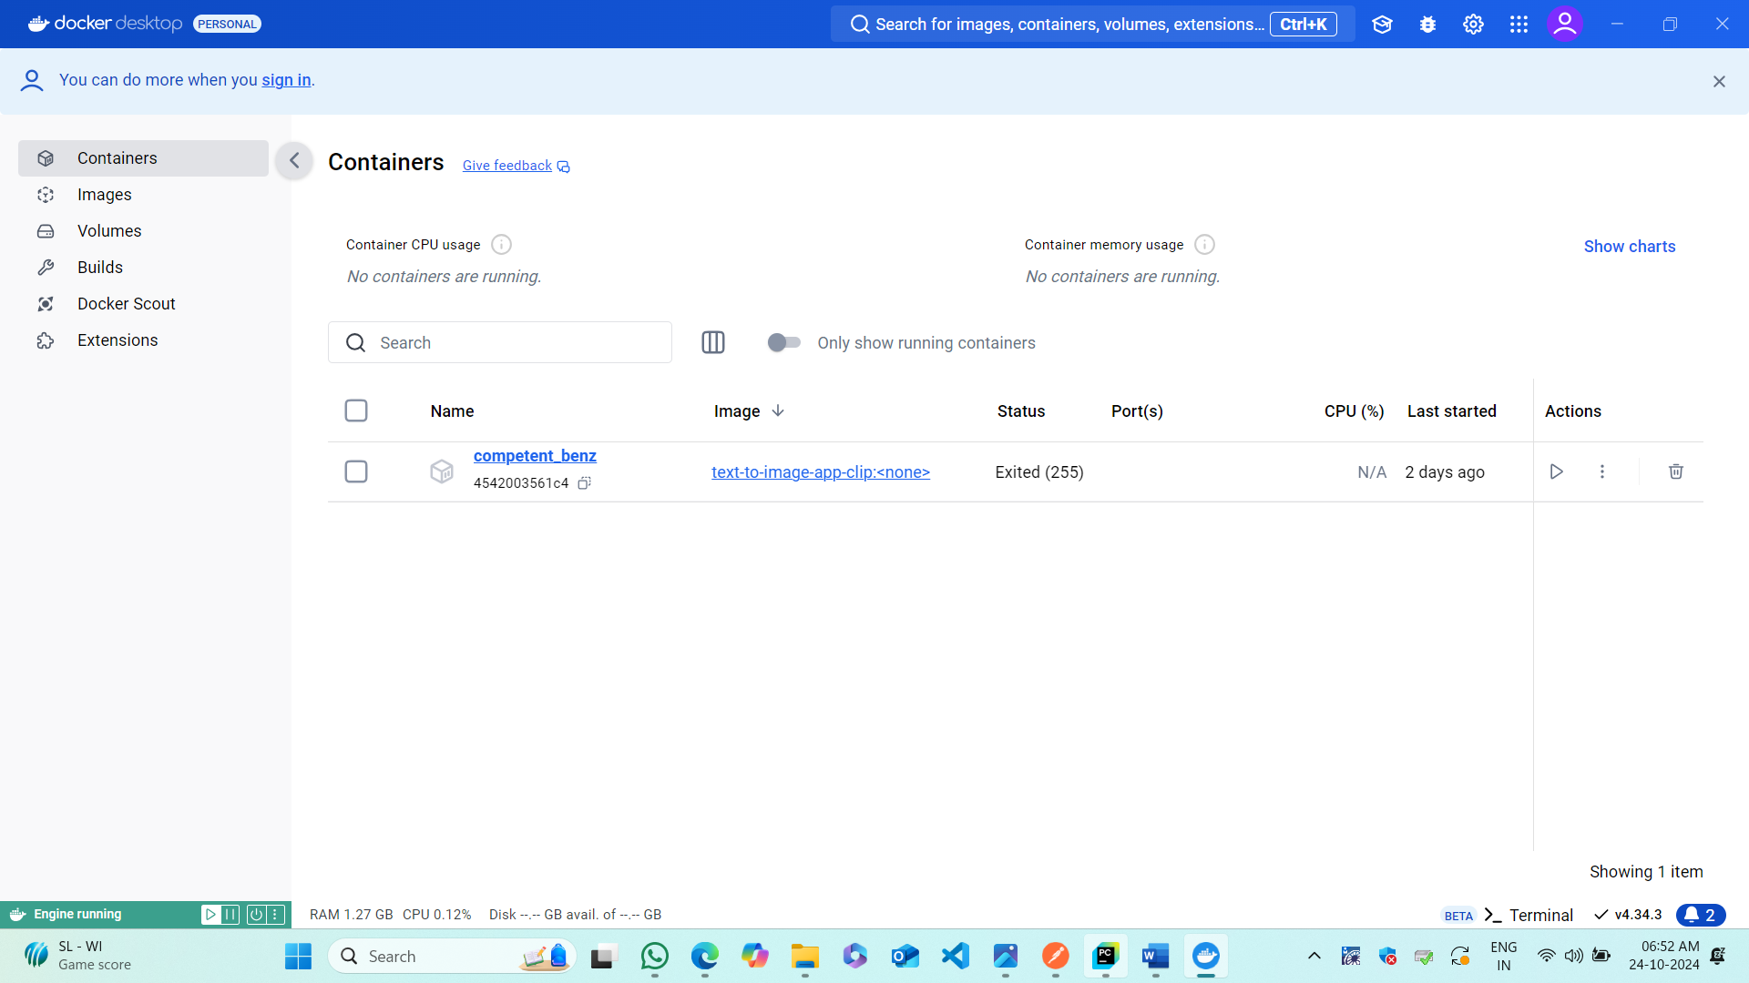

**Container in running Stage:**

